GEM & JEWELLERY SHOW
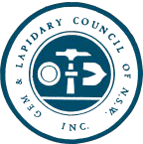
30th September to 2nd October

Hours: 9am to 5pm Saturday & Sunday
9am to noon Monday
Location:
Hawkesbury District Agricultural Grounds at Clarendon, near Richmond

GEMKHANA 2017

Staged by
The Gem & Lapidary Council of NSW Inc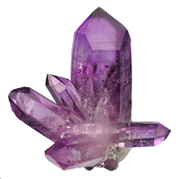

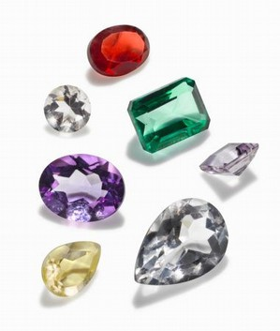We invite you to view the best of our craft in NSW

Examples will include
- Hand crafted Jewellery
- Polished Stones (Cabochons)
- Stone Carving
- Faceted Stones
- Minerals

Traders will be offering: Jewellery, Lapidary Equipment,
Faceting Rough, Rough Stones and Slabs
Carving, faceting & jewellery demonstrations.
Children’s Activities

Adults $5.00 Children $3.00 Family $12.00
Enquiries: - Bob McLean 0429 804 580

